**LIT ASSIGNMENT- DAY 9**

**Batch: SAP ABAP ON HANA.**

**EMP ID : 46255236**

**Exercise 1 – Table Enhancement Using Append Structure**

**Requirement:**

**Append custom fields ZZDISCOUNT1 to ZZDISCOUNT5 in the standard table SFLIGHT.**

This table is used to store flight details such Flight Date, Airfare, Maximum capacity in economy class, and Occupied seats in economy class for an airline carrier and needs to be enhanced to store discounts available for each flight if applicable.

**Transaction –** Use your own Tcode like ZYP01…ZY to display data

* Go to Data Dictionary transaction SE11  
   Display the Table  
   Select option Go To -> Append Structure

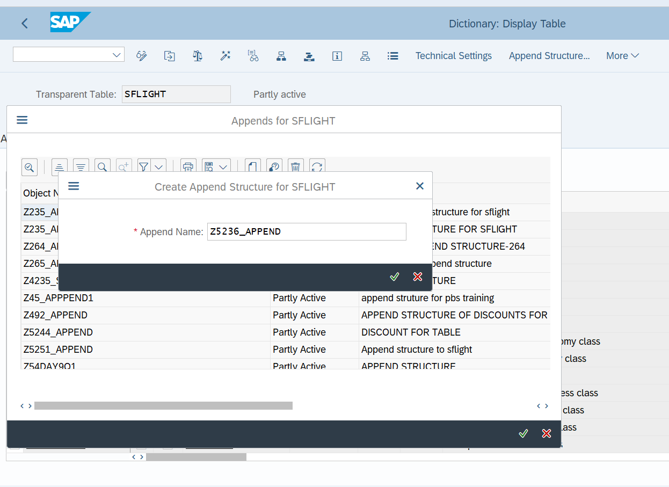

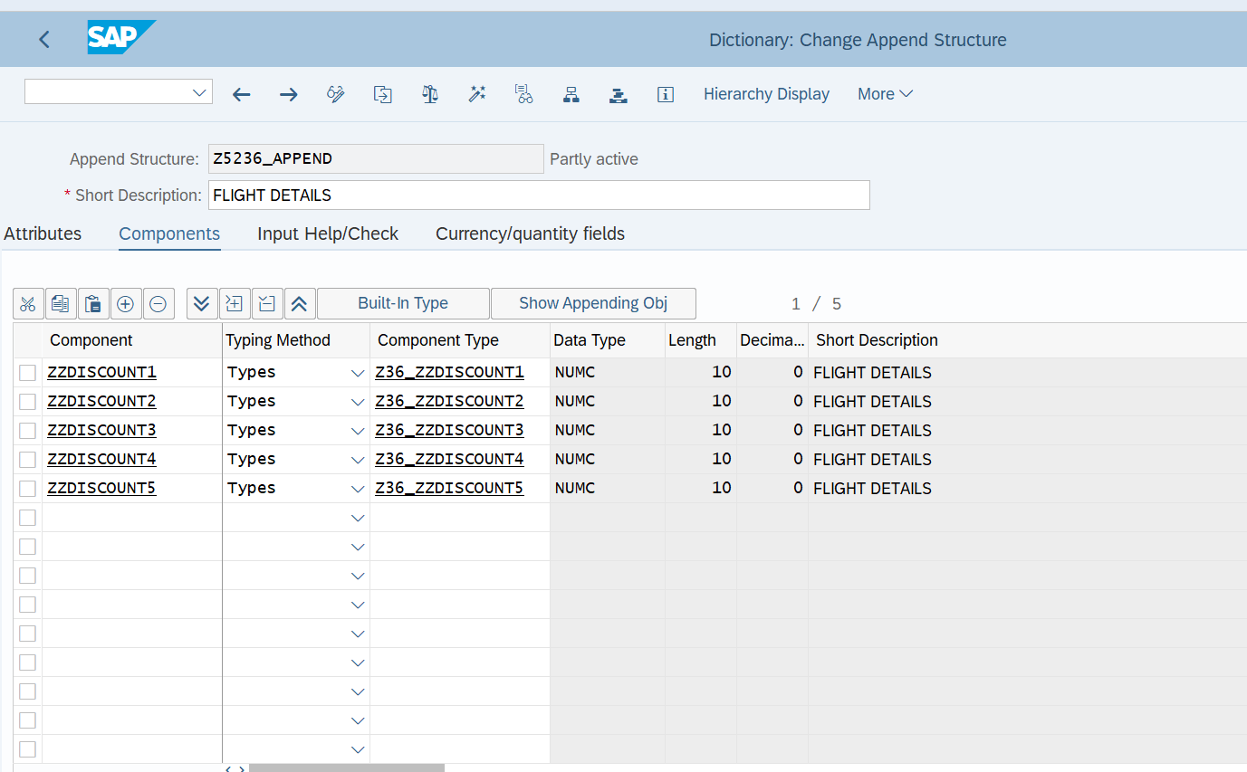

**Exercise 2 – Table Enhancement Using Customizing Include**

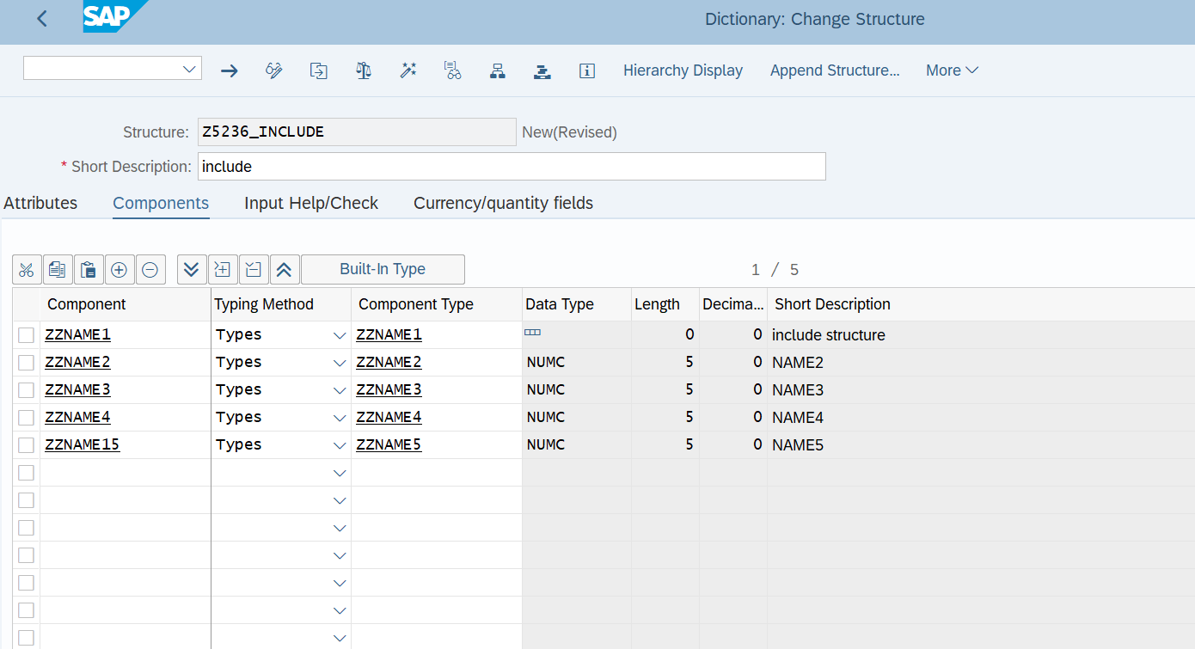

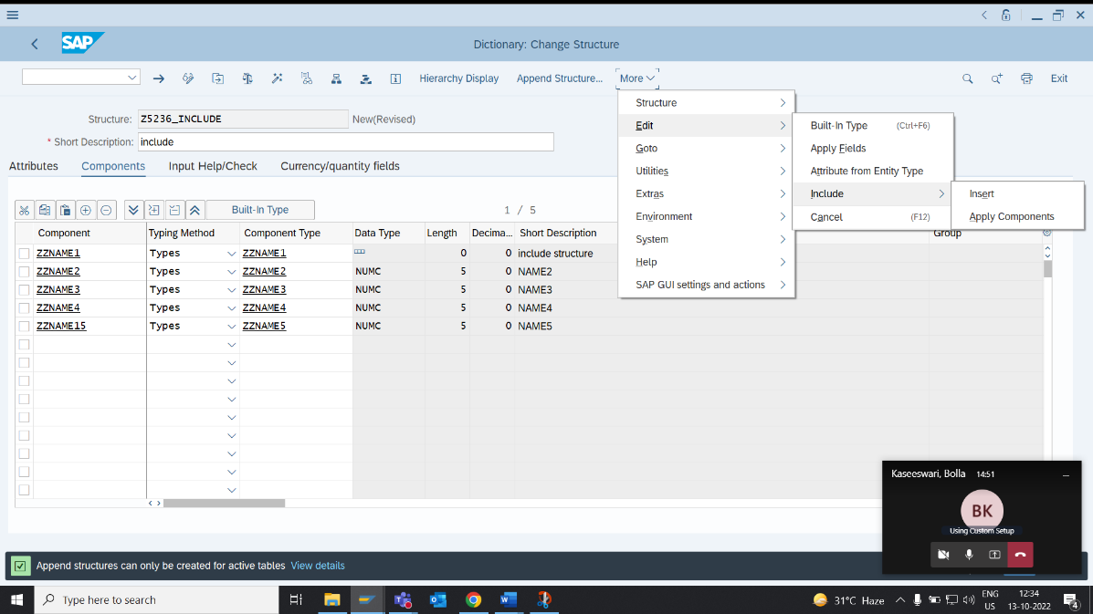

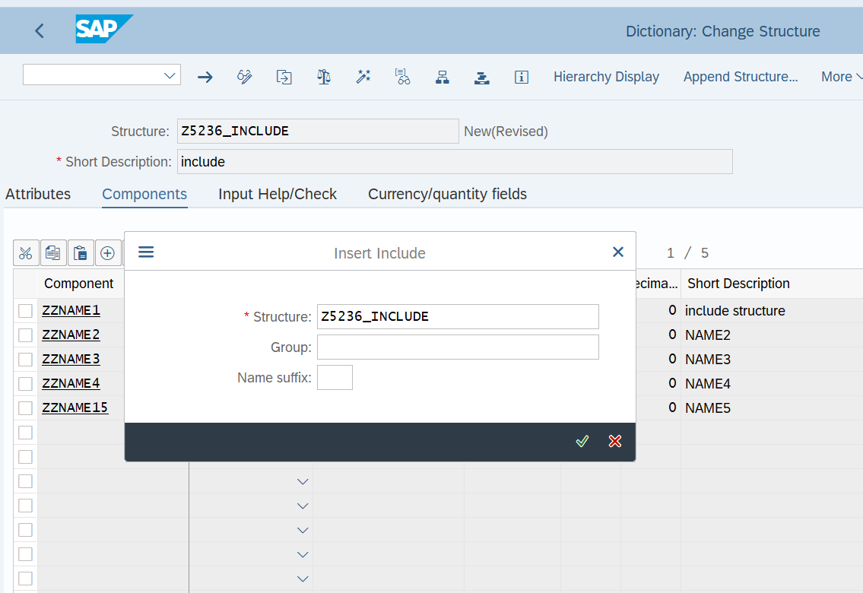

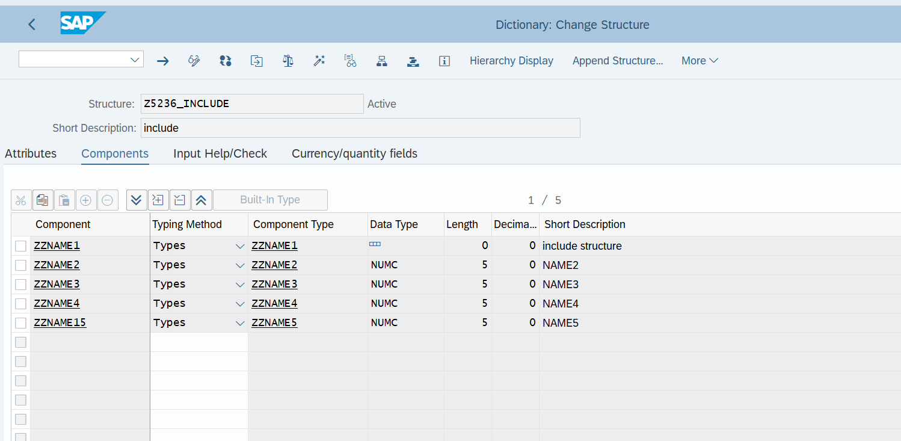

* Append custom fields ZZNAME1 to ZZNAME5 in the standard table EKKO *using* customizing include if available.

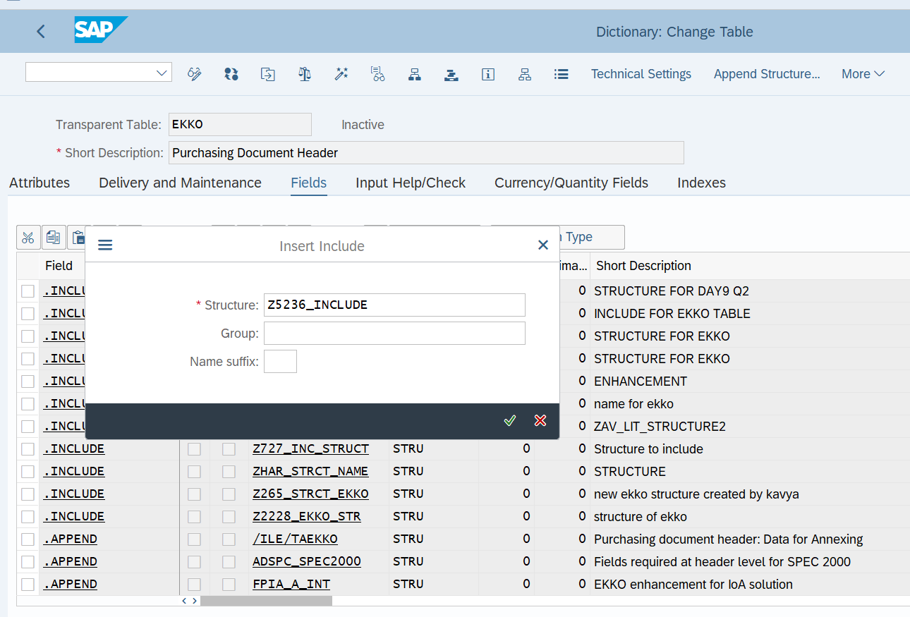

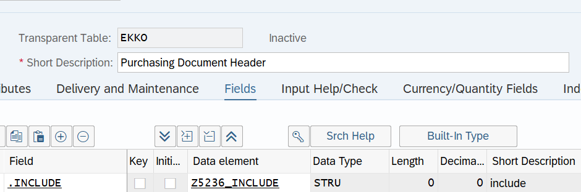

**Exercise 3 – Text Enhancements**

* Execute transaction CMOD.

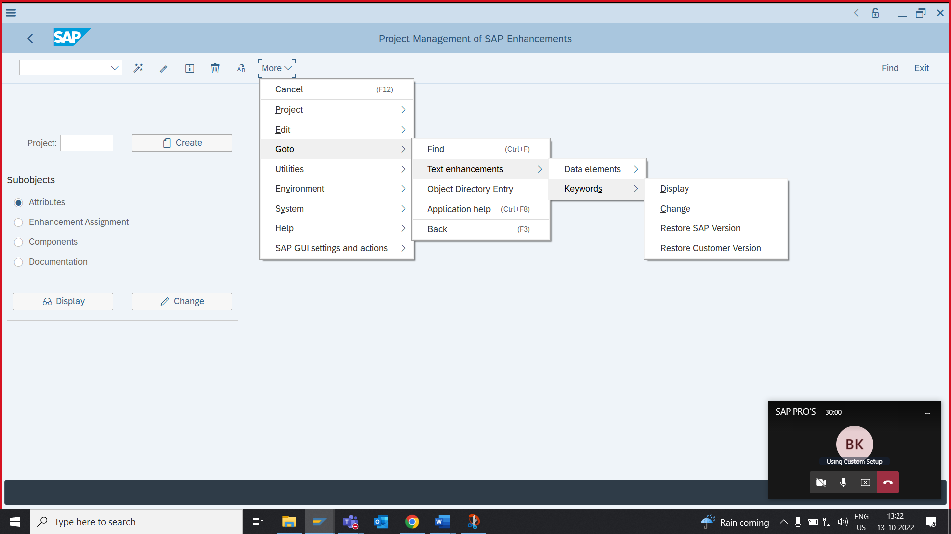

1. Airline Carrier should be renamed as Carrier Name.
2. Connection Number should be renamed as Flight Number.
3. Flight Data should be renamed as Carrier Date.
4. Airfare should be renamed as Carrier Fare.
5. Plane Type should be named as Carrier Type

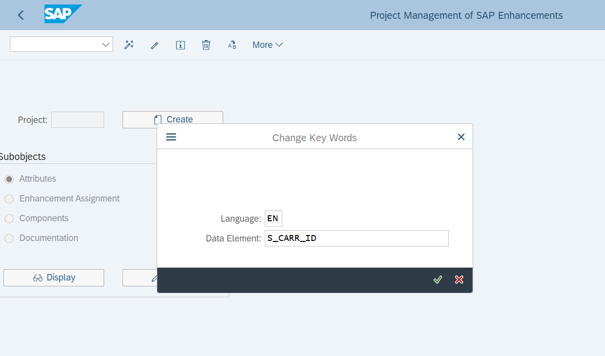

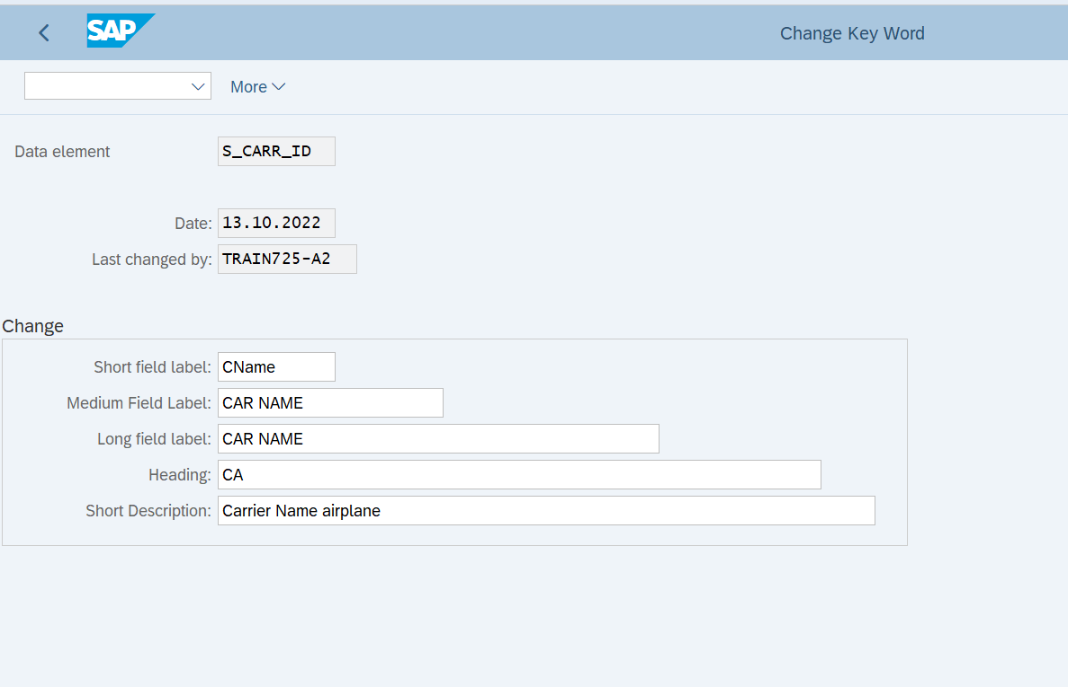

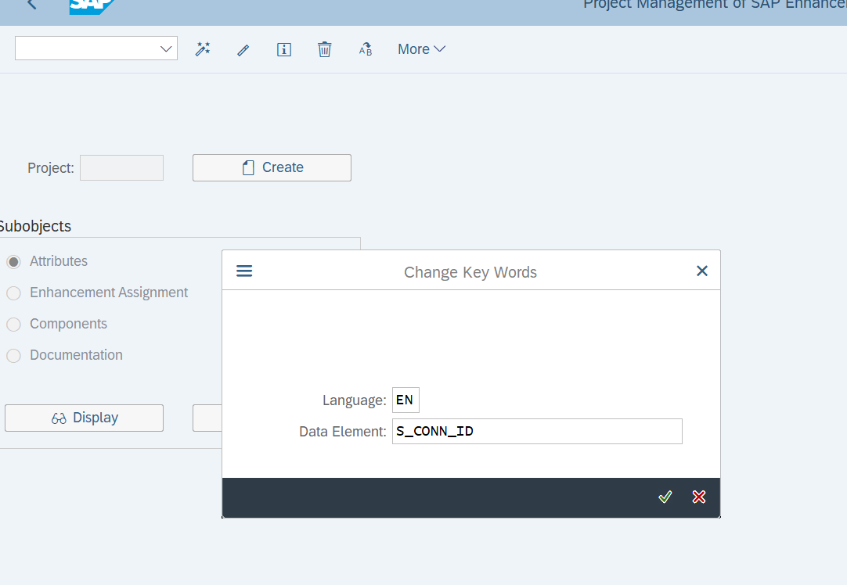

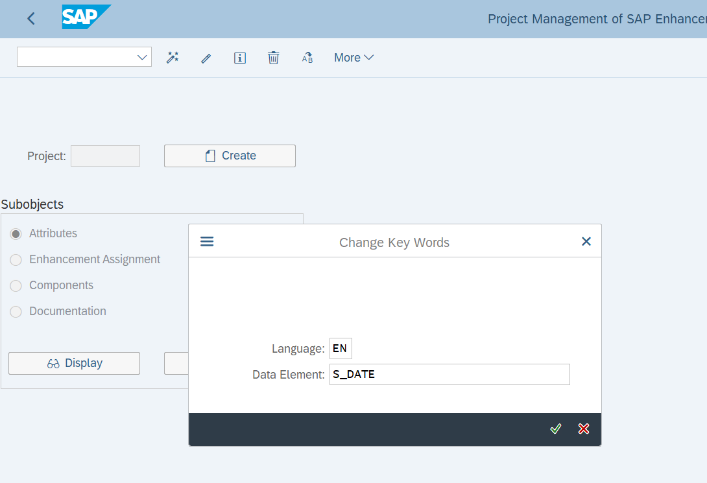

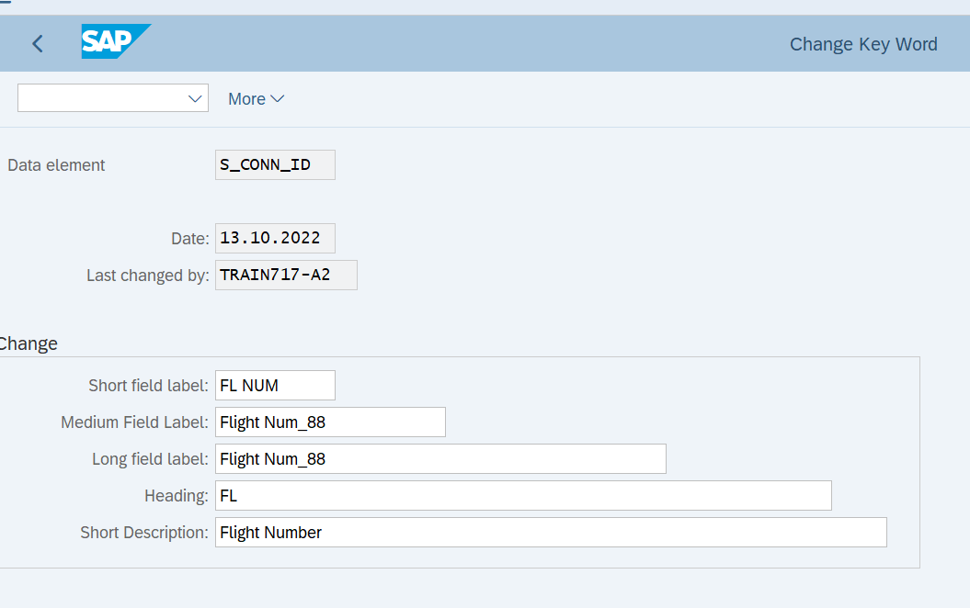

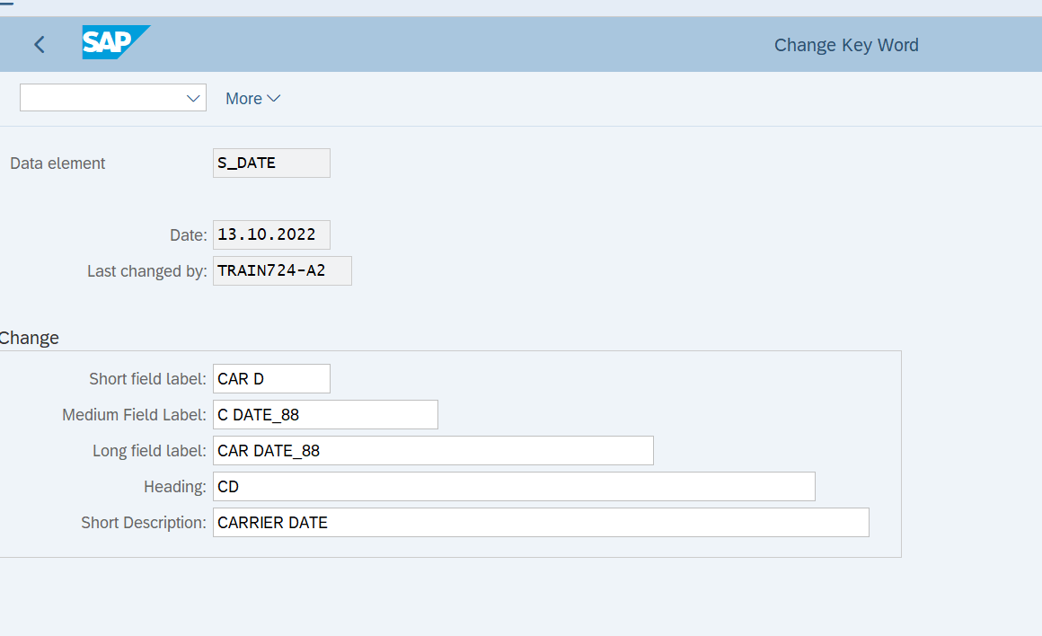**'**

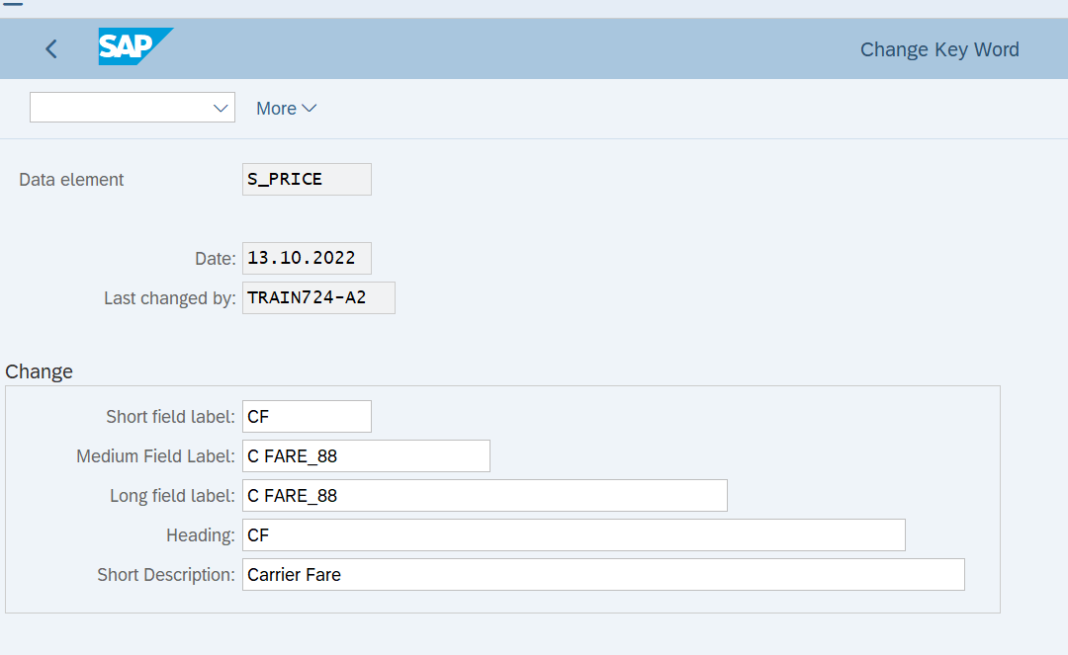

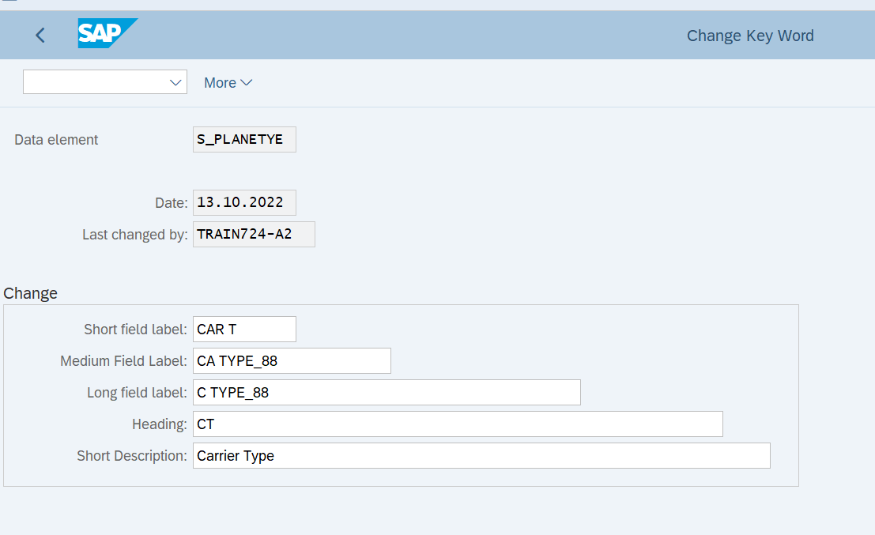

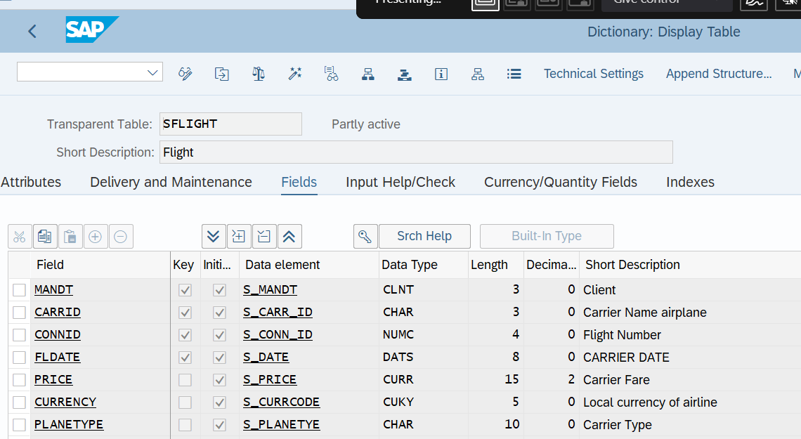

DOCMENTATION:

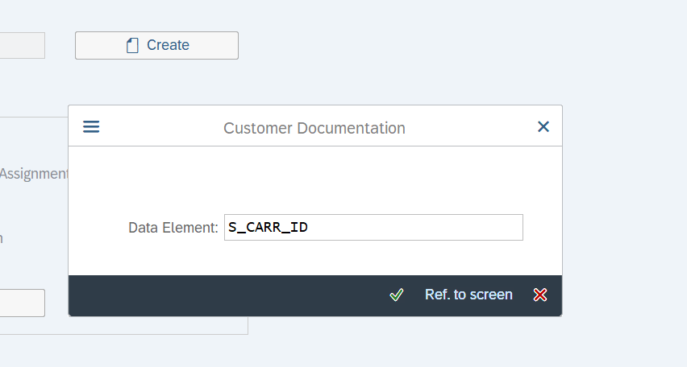



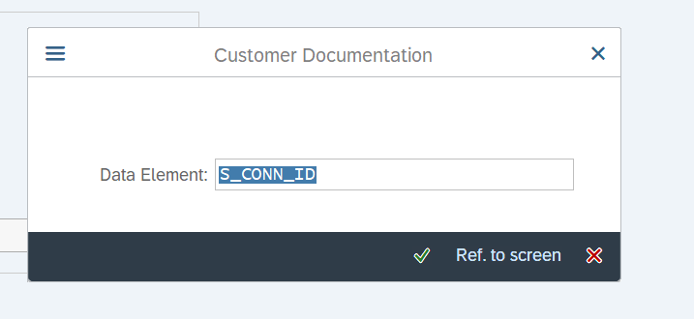



**`**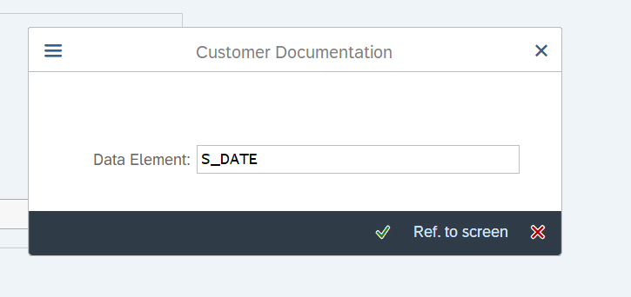



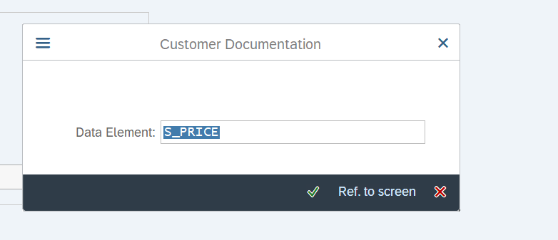



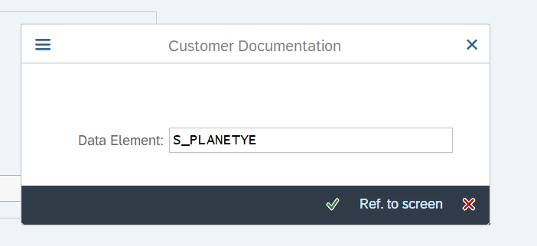



**Exercise 4 – Customer Exits**

* Go to transaction CMOD
* Create a project called ZMM01.

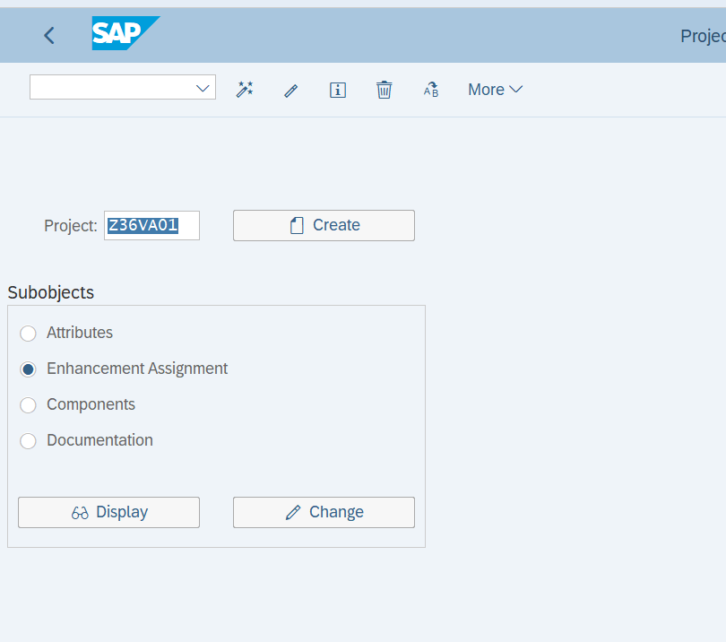

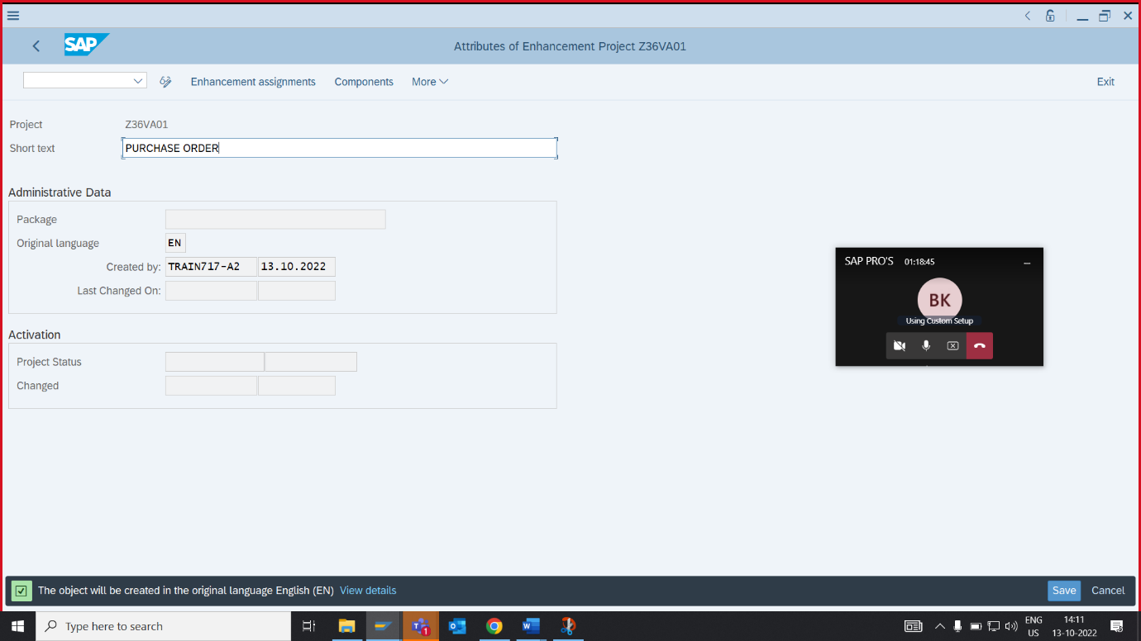

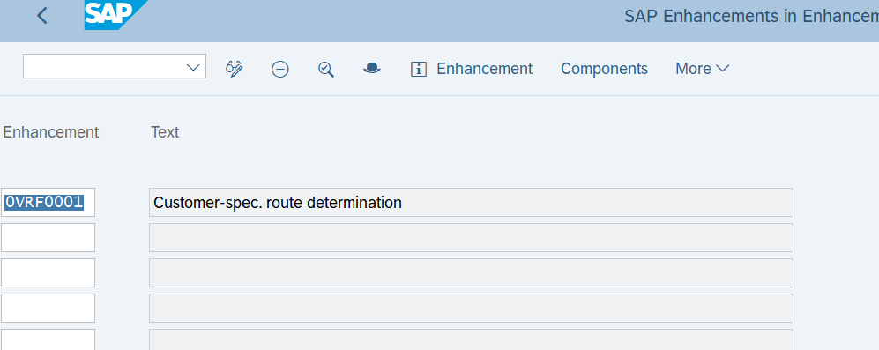

* Go to the Components tab. You can now see that enhancement uses user exit EXIT_SAPMV45A_002. Double click on the exit.

